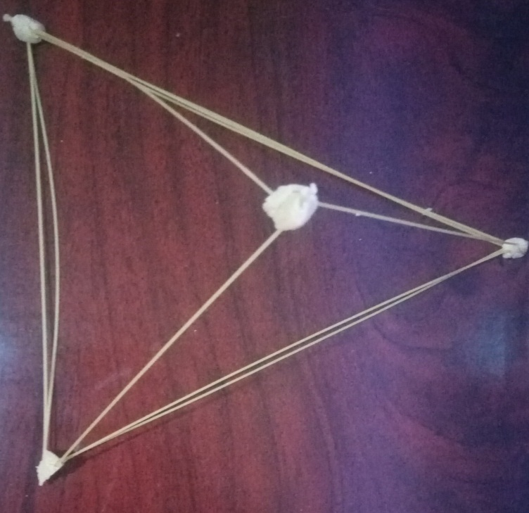

A picture of a spaghetti structure joined together to form a structure in response to the marshmallow challenge

A brief description
The marshmallow challenge focuses on the significance of adequate planning supported by a strong motivation to design and build a strong structure that is able to sustain all the challenges. This is not just an activity for team building. For a structure to be strong it has to have a strong base first which is why in project planning for construction the foundation is to build to withstand time. The second factor to be considered is to focus on starting with the marshmallow, and then build prototypes, successive prototypes, always keeping the marshmallow on top.

